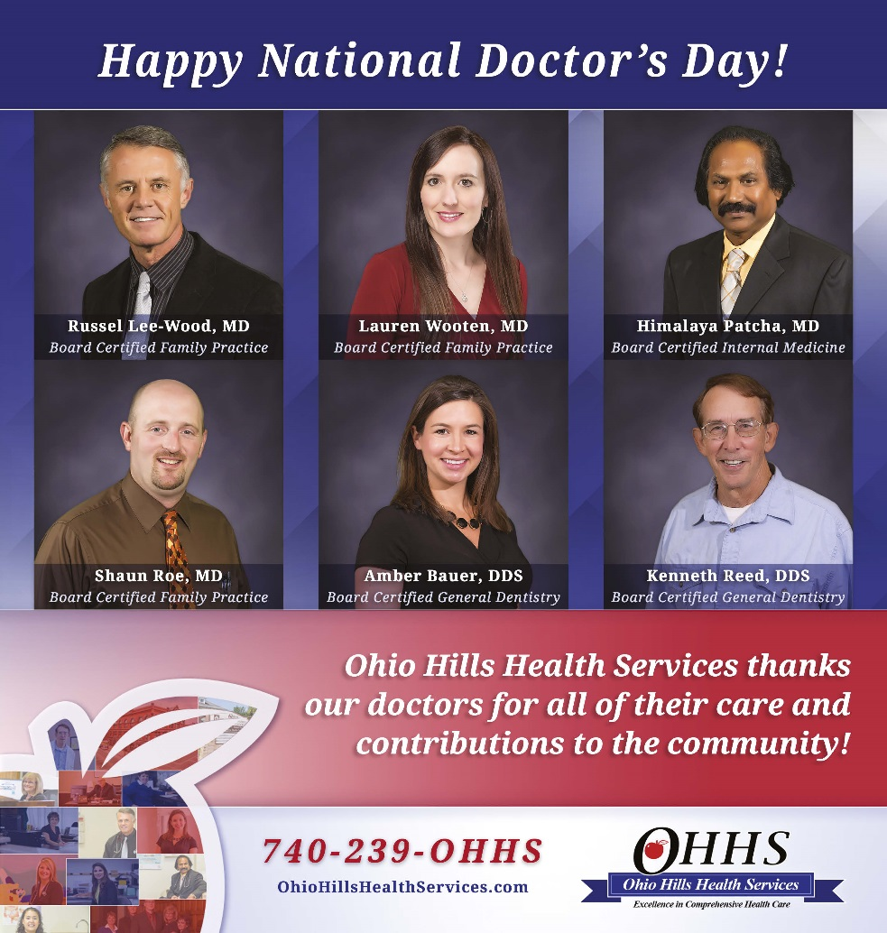
Friday, March 30, 2018, is National Doctor’s Day. Ohio Hills Health Services is served by 6 doctors who provide care to patients in Belmont, Guernsey, Harrison and Monroe counties. Together they have decades of medical experience and are dedicated to serving the communities of Barnesville, Freeport, Quaker City, Woodsfield and surrounding areas.
“National Doctor’s Day recognizes the contributions physicians make to patients and communities. Ohio Hills Health Services is very proud of our doctor’s and the care they provide to our service area every day,” OHHS CEO Jeff Britton said.
Russell Lee-Wood, M.D. has been Medical Director of Ohio Hills Health Services and part time emergency room physician at Barnesville Hospital since August 1996. He is a member of the Board of Trustees at the hospital. At OHHS he supervises all medical activities for four offices which employ a total of 75 employees.
Dr. Lee-Wood has been a medical officer in the Medical Corps, U.S. Army Reserve since December 1998. His military service includes the ICU at the U.S. Army Hospital in Afghanistan from June-September 2002; 150 Engineer Battalion, Iraq from April to August 2005; Task Force Med Falcon, Kosovo December 2010- March 2011, Task Force Bravo, Honduras Sept. - Dec. 2013, and flight surgeon in the U.S. Army Reserve in April 2011.
In addition to Barnesville Hospital, his clinical affiliations also include Harrison Community Hospital and the 339th Combat Support Hospital, Corapolis, Pa.
He is board certified in Family Practice and is a member of the American Medical Association, American Academy of Family Physicians, and Association of Military Surgeons of the U.S. He us an attending physician in family practice at OHHS’s Freeport Family Health Center and has admission privileges and committee membership at Barnesville Hospital.
He earned his medical degree from St. George’s University School of Medicine in Grenada, West Indies in 1992, after earning his Medical Science degree in 1979 from Bradford University, graduating from the Royal Military Academy in Sandhurst, U.K. in 1980 and earning a BA from Open University, Milton Keyes, U.K. in 1987. He received his clinical training at Royal Hampshire County Hospital, United Kingdom. He did his internship at Somerset Medical Center in Somerville, New Jersey and his residency at Kingston Benedictine Hospital in Kingston, New York. He became a Fellow of the American Academy of Family Practice in 1999.
Awards Dr. Lee-Wood has received include the International Peace Scholarship, 1988-1992, Chancellor’s Award for Clinical Achievement in June 1992, Lou Neporent Award for Clinical Excellence in July 1995, US Army Commendation Medal in a mission to El Salvador in 2001 and a Bronze Star in Afghanistan in 2002.
His interests include running, cycling, scuba, reading, and military history.
Shaun Roe, D.O. is a family practice doctor at the Quaker City Family Health Center and Morristown Family Practice. He is also affiliated with Barnesville Hospital. He graduated from the Ohio University College of Osteopathic Medicine in Athens, Ohio. He did his residency at Wheeling Hospital. He is a member of the American Academy of Family Physicians, American Academy of Osteopathic Family Physicians, American College of Physicians, American Osteopathic Association and the Ohio Osteopathic Association.
Himalaya Patcha, M.D. has worked at Ohio Hills Health Services since 1993. Prior to that beginning in 1990, he did his residency in internal medicine at the Ohio Valley Medical Center. From 1989 to 1990 he worked under Dr. Lentino, Chief of Infectious Diseases, VA Hines, Chicago. In 1986 he immigrated to the United States and became a U.S. citizen. Prior to that, from 1984 to 1986, he was Senior House Officer of Internal Medicine of the Government Royapettah Hospital in Madras, India. From 1983-1984 he was a medical officer at The Best Hospital in Madras. From 1980-1983 he was a general practitioner in Madras. He earned his undergraduate degree from the Government Arts & Science College in India from 1969-1972 and his post graduate degree from S.V. University, India from 1972-1979.
He is a member of the American College of Physicians and the American Medical Association. He is licensed in both Ohio and West Virginia and is American Board of Internal Medicine certified.
Dr. Patcha received the Best Outgoing Resident Award at Ohio Valley Medical Center, graduated with honors in undergraduate course, represented the Medical College and University in field hockey at the national level and served Lions Club International. Dr. Patcha has also published many medical papers and given many presentations on medical topics.
Lauren Wooten, M.D. joined Ohio Hills Health Services in 2016. Certified by the American Board of Family Medicine, Dr. Wooten sees patients at Freeport Family Health Center and Monroe Family Health Center. She has a clinical affiliation with Barnesville Hospital. Dr, Wooten graduated from the University of Sint Eustatius School of Medicine in Saint Michael, Barbados. She did her residency at Summa Barberton Hospital. She received the ManorCare Barberton Resident of the Year award. Dr. Wooten is a member of the American Academy of Family Physicians and the Ohio Academy of Family Physicians.
Dr. Wooten’s goal is to “provide quality healthcare at an affordable cost.” Her special interests include weight management, diabetes, hypertension, and performing procedures.
Dr. Amber Bauer and Dr. Ken Reed are dentists at the Freeport Family Health Center’s dental clinic.
Kenneth C. Reed, DDS provides complete family dental care. Dr. Reed has his own dental practice in Cambridge until his retirement in 2006 and joined the Freeport Family Health Center Dental Program in May of 2008. Dr. Reed remains active with the US Army Dental Corps. He is a graduate of the Ohio State University College of Dentistry.
Amber Bauer, DDS provides complete family dental care. Dr. Bauer is a graduate of the West Virginia University of Dentistry and joined the staff at the Freeport Family Health Center Dental Program in July 2009.
Ohio Hills Health Services is a non-profit health care operation, organized by communities in Eastern Ohio to promote healthy lifestyles and to provide comprehensive treatment and preventative services for area residents. The primary focus is to provide prompt, courteous and affordable health care that is responsive and sensitive to individual needs.

